Analysis of Algorithms
Mason Vail
CS 221

Algorithm 1: Find

Section 1: Preliminary Analysis
The first for loop goes through as many times as the size of n. Therefore it would be true that the First part of the equation would be...
T(n) = n + …
and then take into account the if loop runs...
T(n) = n * n + …
now adding all of the loop initializations, condition checks, and returning values we get…
T(n) = 2(n * n)
as the longest possible run for any given int entered. With this we get a a quadratic equation
O(n^2): 2n^2

Section 2: Collected Data
size statements
1000 1005000
10000 100050000
20000 400100000
30000 900150000
40000 1600200000
50000 2500250000
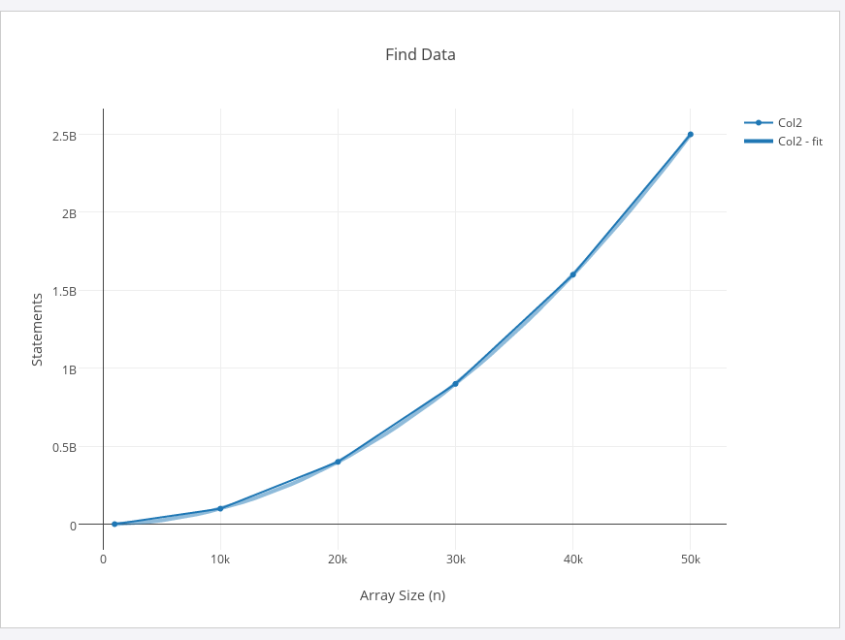
The above graph represents the data collected from running the program, and a quadratic line function. The darker blue (dotted line) is the data representation.
As you can see from the graph, the data is parallel to the nature and shape of a quadratic equation, making the Big-O run-time quadratic definitely.

Algorithm 2: Order
The first for loop will go over the entire array length, possibly, so I would start with…
T(n) = n
The while loop will go through a number of steps depending on the origional for loops next value. For example, if it was the 4th time the for loop was run, the while loop would run 4 times at the most. So now we have…
T(n) = n+4^n
4 because of the number of statements enacted every time the while loop is enabled. Finally, adding the number of statements in the starting for loop, we get…
T(n) = 2n+4^n
This equation comes out to be a logarithmic equation, giving it the Big-O runtime as logarithmic or
O (logn)

Section 2: Collected Data
size statements
1000 1009404
10000 100484016
20000 399427344
30000 903412660
40000 1585231128
50000 2495200856
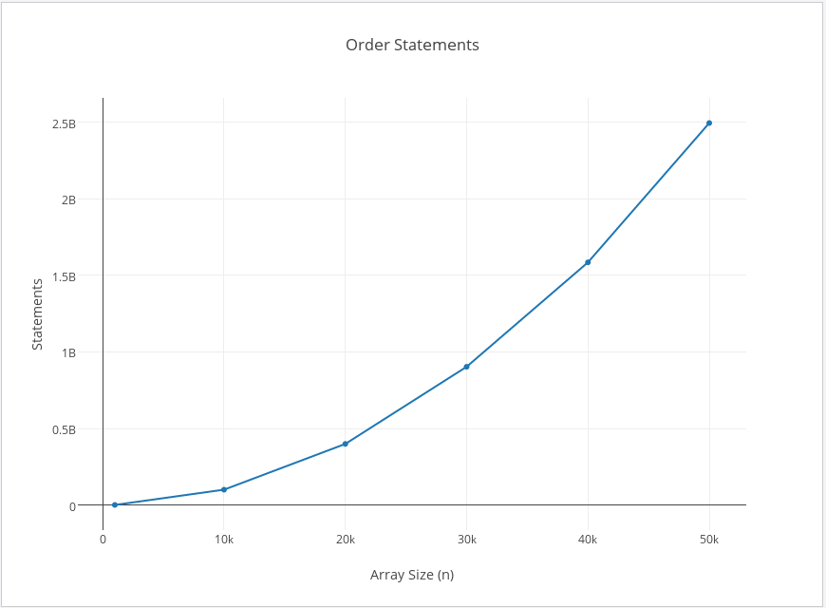

Section 3: Final Analysis
Judging from the numbers from the Order class, I can see that they are very similar to the Find's number of statements. From this conclusion I am going to change my mind to the state at which the equation is for my conclusion to O(n^2)

